# **Great North Air Ambulance Bag Collection & Coffee Morning**

# **Saturday 9th July 2022**

**Warcop Parish Hall 10:00 – 11:30 am**

**Please leave bags OUTSIDE the Hall on the car park side**

**(Please note: bags collected by GNAA van which will leave at 11:30 am)**

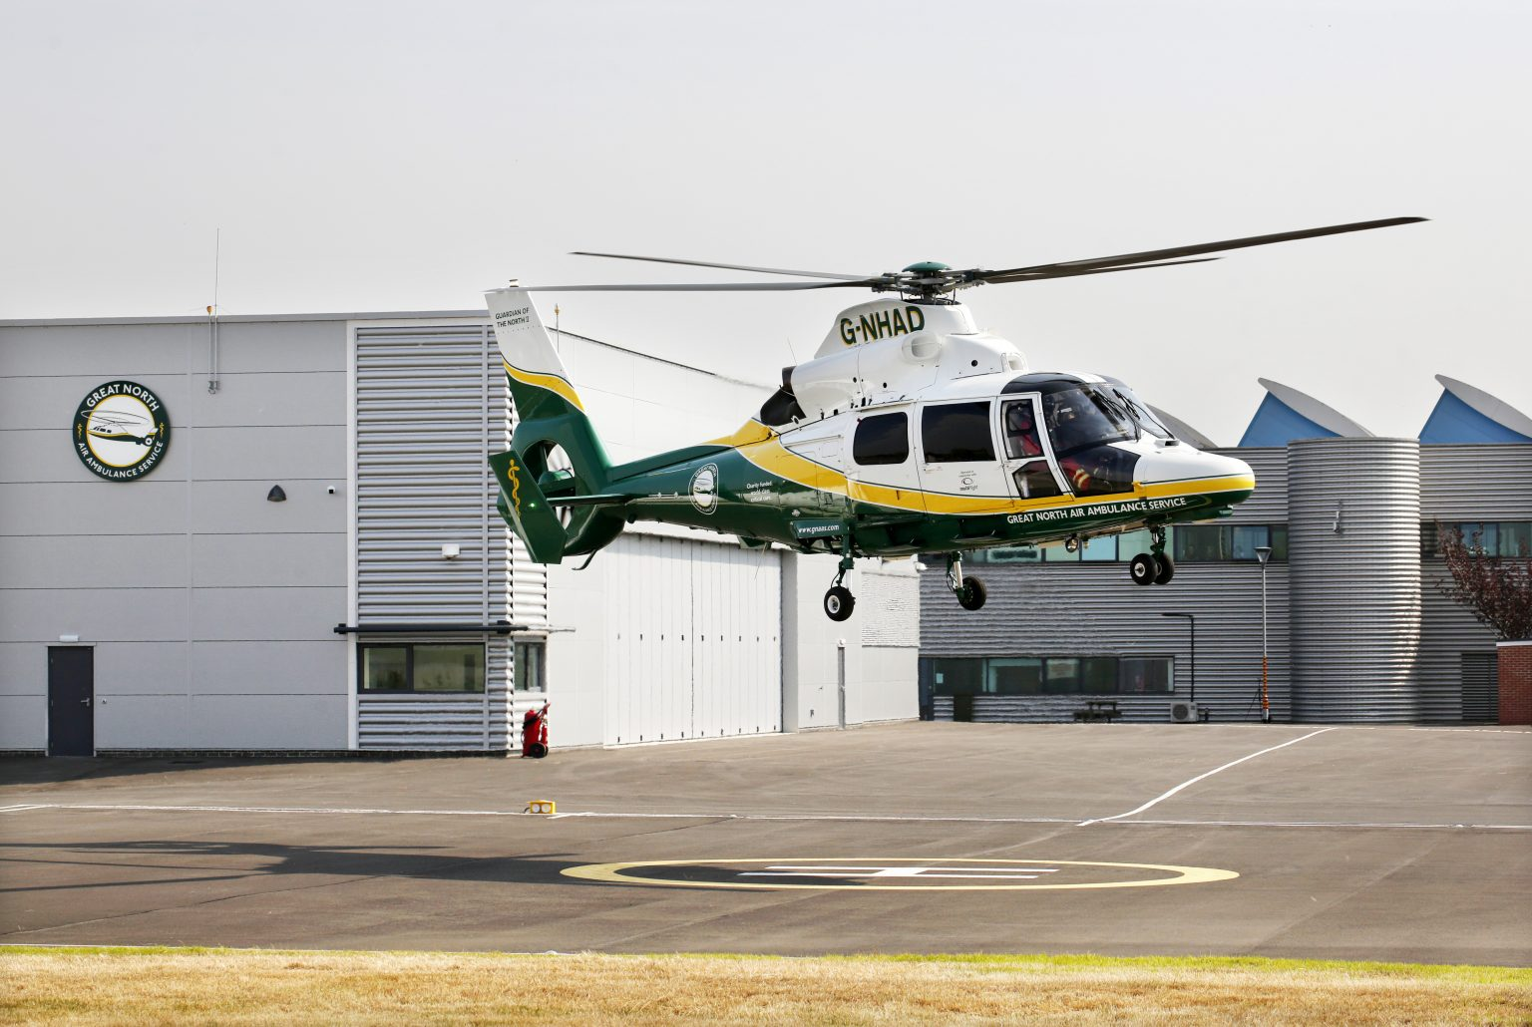

**Please donate your unwanted items to support the Great North Air Ambulance charity and help them to ease suffering and save lives in our rural area. They need £4.5 million per year to maintain the service. All proceeds from this re-cycling go to them. Visit** [**www.greatnorthairambulance.co.uk**](http://www.greatnorthairambulance.co.uk) **for more information. Do then join us for a cuppa and a chat at the Coffee Morning.**

**Why not use this as a chance to have a summer clear out and bring items listed below to the Hall? Please note that bags will only be available in the newspaper boxes in Sandford and Warcop. Kindly leave bags *outside* the Hall ready for the van collection at 11:30am. More bags available by phoning 41390. Thank you.**

* **Clothing**
* **Bags**
* **Footwear**
* **Bed linen, towels & curtains**
* **Books, CDs & DVDs**
* **Mobile phones**
* **Ink/toner cartridges**
* **No bric-a-brac or electrical items please**

**Website:**[**www.warcop.org.uk**](http://www.warcop.org.uk)

**Phone: 017683 41390**

**Warcop Parish Hall**

**CA16 6NX**

