ART & CRAFT EXHIBITION 2022
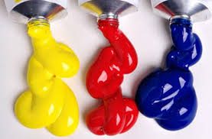
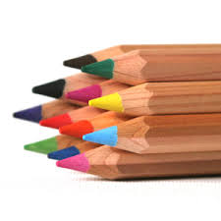
Warcop Parish Hall

Calling All Local Artists & Craftspeople!
We’d like to hear from you if you are:
- Art groups
- Painters
- Sculptors
- Photographers
- Felt makers
- Craft workers
- Woodturners
- Ceramicists
- Local schools
- Sugar crafters
- Needlecrafters
- Art teachers
Following four highly successful Art & Craft Exhibitions, and the cancelled Covid ones in 2020 and 2021,we are pleased to announce our fifth annual exhibition in our bright Warcop Parish Hall over the early Bank Holiday weekend:
Saturday 30th April – Monday 2nd May 2022, 10 - 4 pm
The event is a celebration of the extensive creative talent in our local community, so we would love to hear from you if you would simply like to display or sell your work to local people and visitors. Set up will be on Friday 29th April 10:00 - 4:00 pm. This year we will again have a Private Viewing event to start our weekend, also on Friday 29th April 7 – 9, including all artists, local VIPs, dignitaries and the media. Again, this year we intend to put on demonstrations and workshops over the three days, run by attending artists/craftspeople for visitors to sign up for in advance. We will publicise the event in the local media, websites, parish magazines and flyers in hotels, B&Bs and TICs.
The hall will be fully staffed over the Bank Holiday period and refreshments will be available. There will be raffle prizes, competitions and activities too.
For further information and to reserve a display space, contact: David Keetley on 017683 41390, Hazel Deighton on 017683 41034, email keetleyjd@sky.com or visit www.warcop.org.uk
