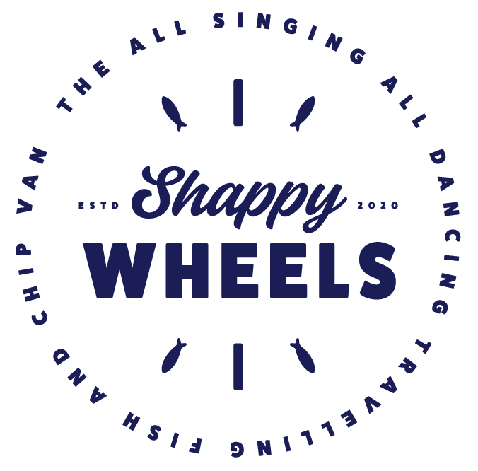
Warcop 2022 Dates

Both our amazing vans are raring to go for 2022 and we can’t wait to serve you up some of our fabulous Fish & Chips

Every 2 weeks on a Tuesday
16:30 – 19:00

4th January | 24th May | 11th October
18th January | 7th June | 25th October
1st February | 21st June | 8th November
15th February | 5th July | 22nd November
1st March | 19th July | 6th December
15th March | 2nd August | Closed for Xmas & New Year
29th March | 16th August
12th April | 30th August
26th April | 13th September | Starting Back for 2023 3rd January
4th January | 27th September
www.shappywheels.co.uk
@shappywheels
07483 – 455910

