# **Great North Air Ambulance Bag Collection**

# **Saturday 10th July 2021**

**Warcop Parish Hall 09:00 – 11:00 am**

**Please leave bags OUTSIDE the Hall on the car park side**

**(Please note: bags collected by GNAA van which will leave at 11:30 am)**

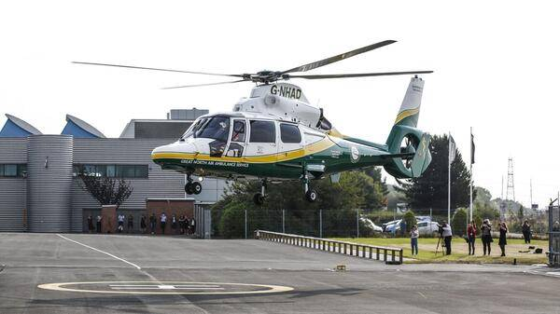



**Please donate your unwanted items which will support the Great North Air Ambulance appeal which helps them to ease suffering and save lives in our area. They need £4.5 million per year to maintain the service. All proceeds from this re-cycling go to them. Visit** [**www.greatnorthairambulance.co.uk**](http://www.greatnorthairambulance.co.uk) **for more information.**

**Why not use this as a chance to have a good post-lockdown clear out and bring items listed below to the Hall? Please note that due to Covid regulations, bags will only be available in the newspaper boxes in the villages. More bags available by phoning 41390. Thank you.**

* **Clothing**
* **Bags**
* **Footwear**
* **Bed linen, towels & curtains**
* **Books, CDs & DVDs**
* **Mobile phones**
* **Ink/toner cartridges**
* **No bric-a-brac or electrical items please**

**Warcop Parish Hall**

**CA16 6NX**

**Website:**[**www.warcop.org.uk**](http://www.warcop.org.uk)

**Phone: 017683 41390**