GENERAL NOTES

- Do not scale from this drawing. Use figured dimensions only. Unless otherwise stated all drawing units are in millimetres. Levels are in meters.
- This drawing to be read in conjunction with all other relevant consultant/specialist drawings and specifications.
- Check levels/dimensions quoted on drawing against those on site before finalising.
- Report any discrepancies before affected work commences.
- For setting out dimensions, see Architect's drawings.
- This drawing remains copyright of Blackett-Ord Conservation Ltd. Copy/distribute only with consent of the Author.

HIGHWAYS ENGLAND DRAWINGS OVERLAYING ORDNANCE SURVEY MAP.

KEY:

EXISTING ROUTE

PROPOSED HIGHWAYS ENGLAND ROUTE PROPOSED NORTHERN ROUTE
AONB
Blackett-Ord Conservation
ENGINEERING
33 Chapel Street, Appleby, Cumbria CA16 6QR - Telephone: 017683 52572 Email: engineering@blackett-ordconservation.co.uk

A66 Improvements
Appleby to Brough: Proposed Routes

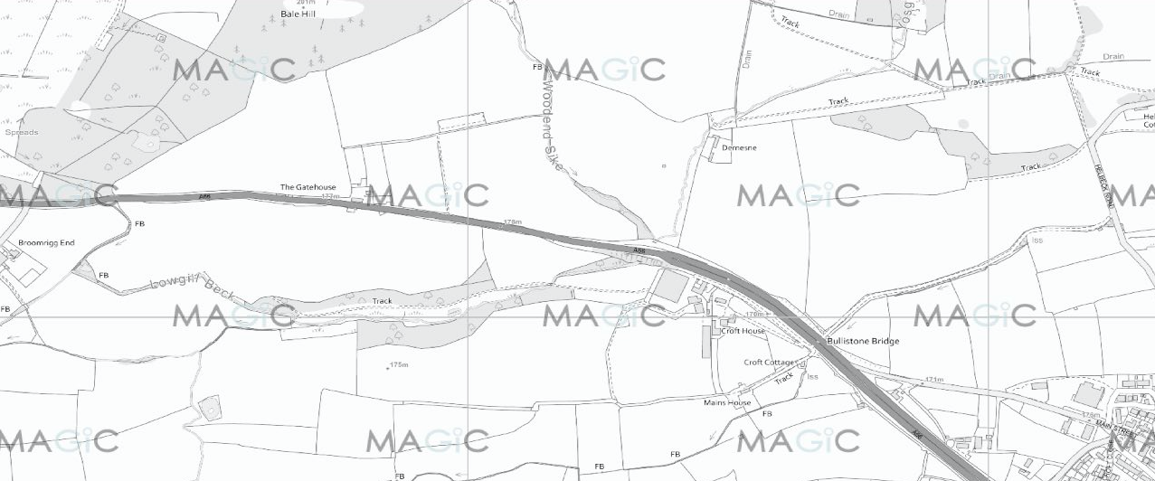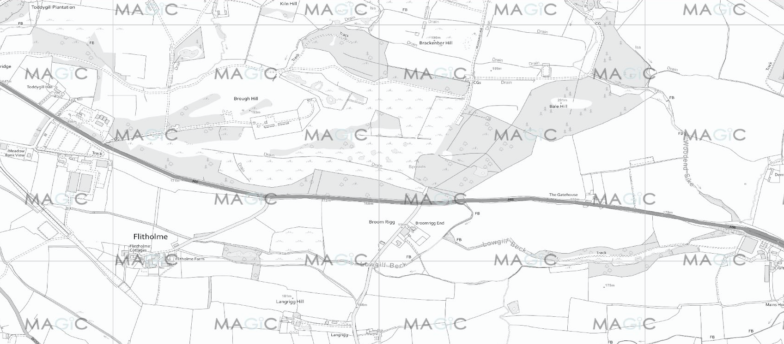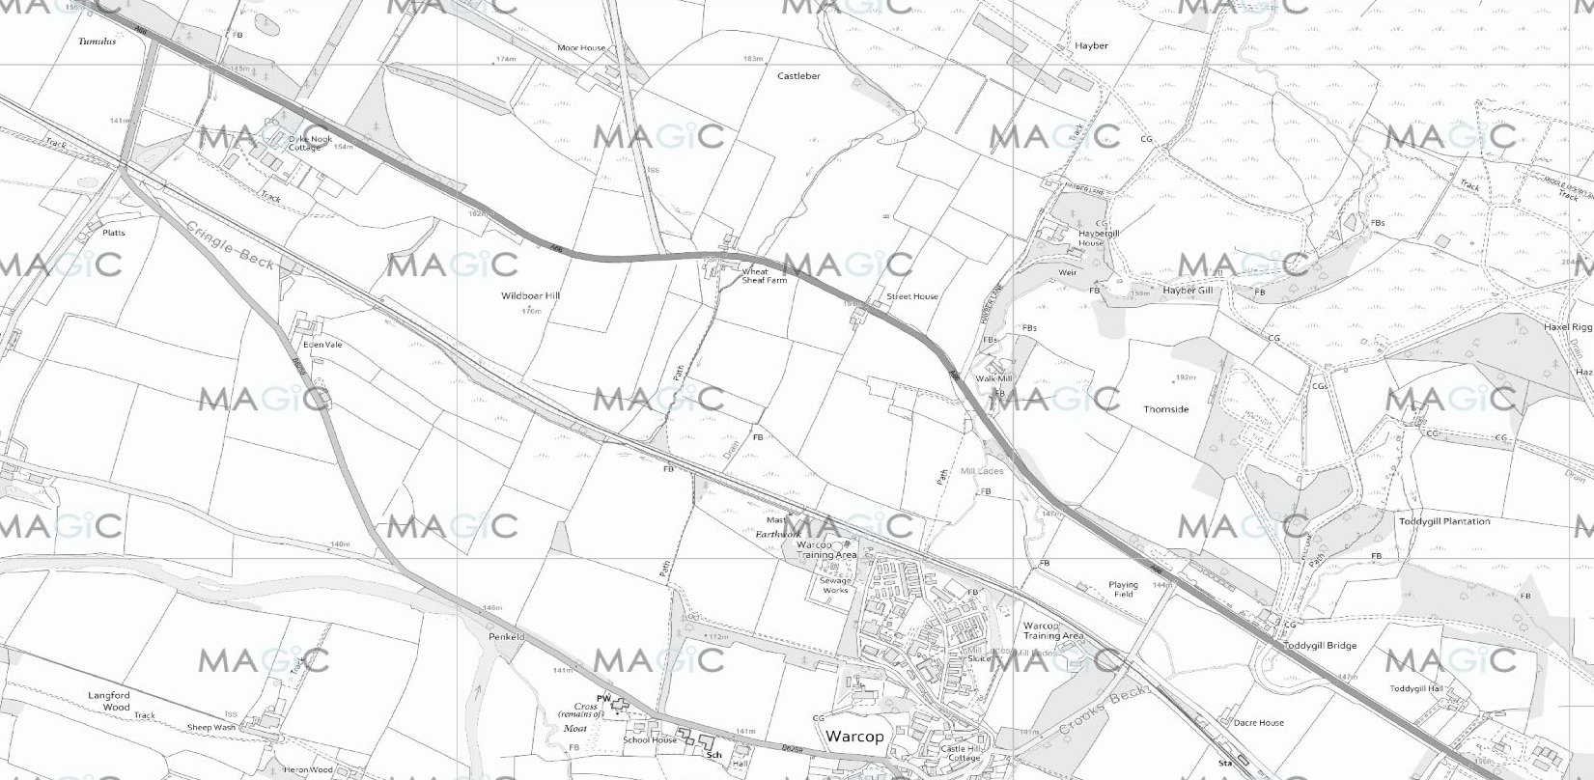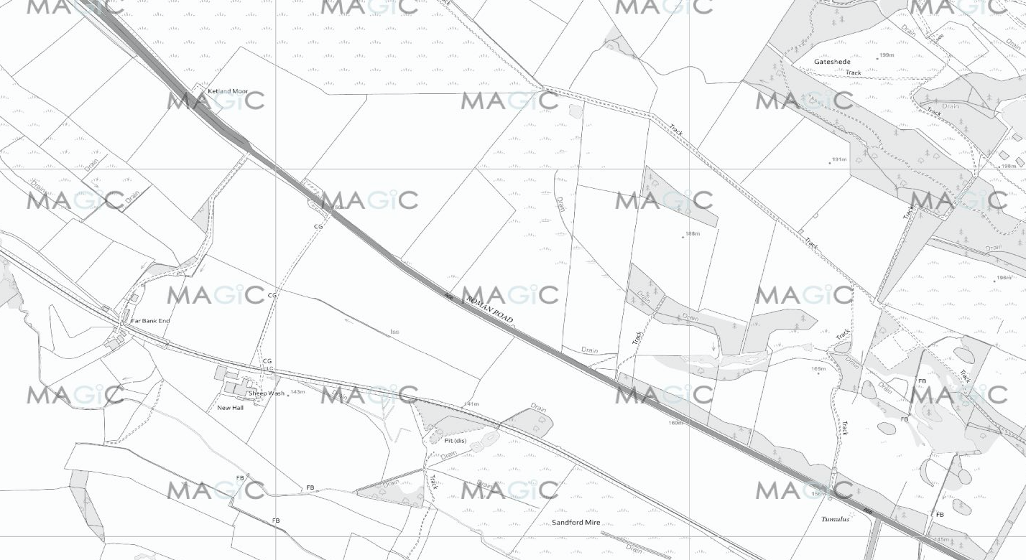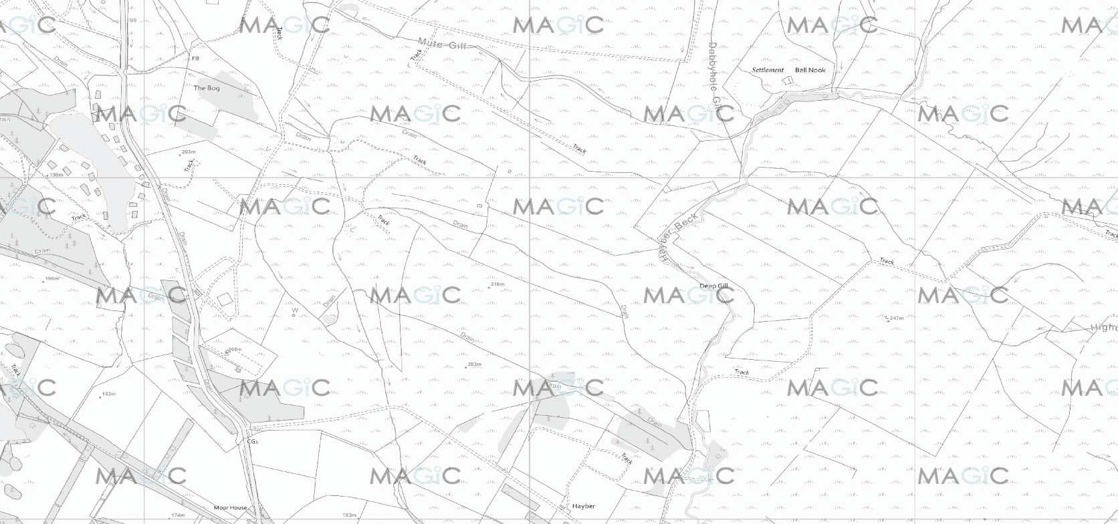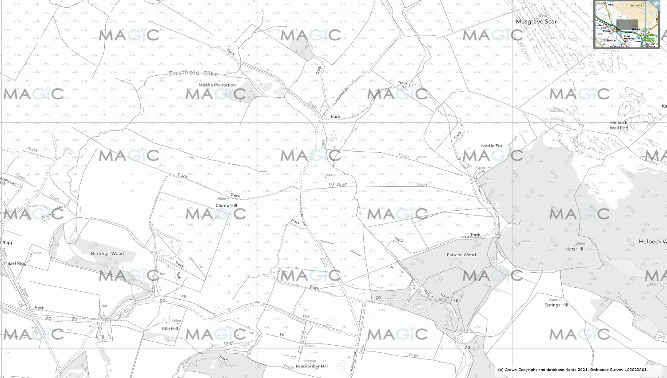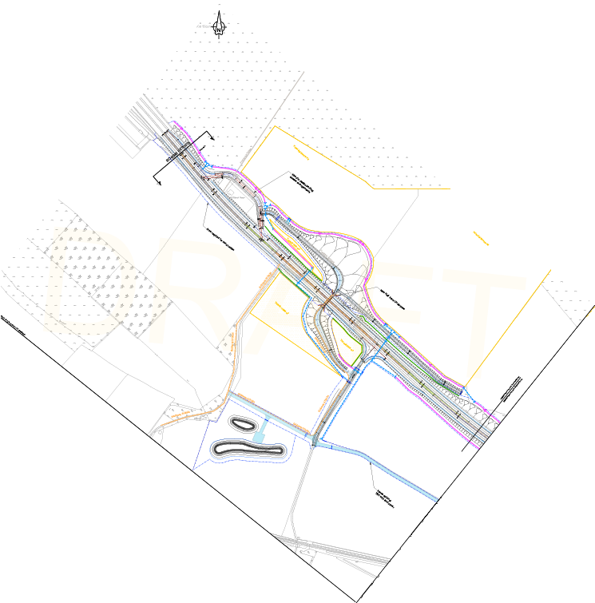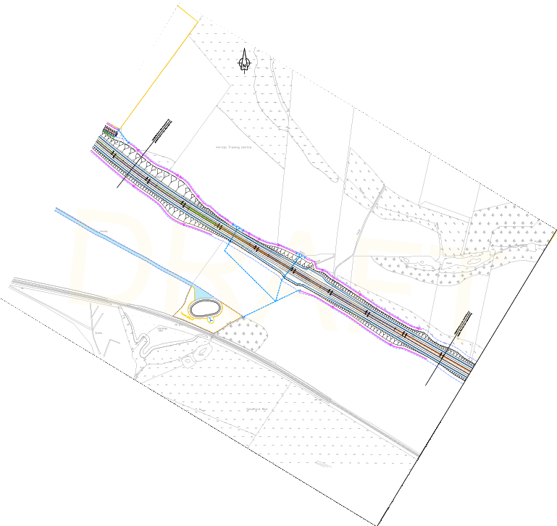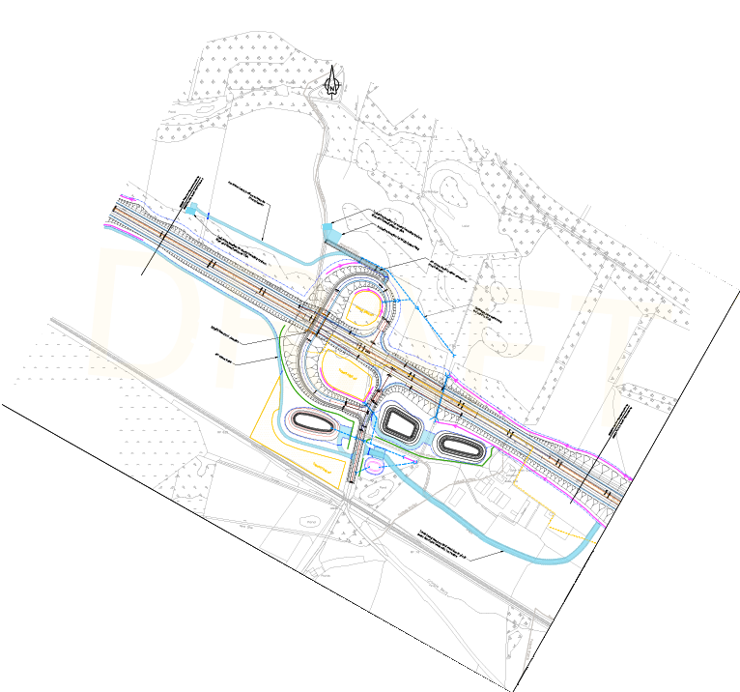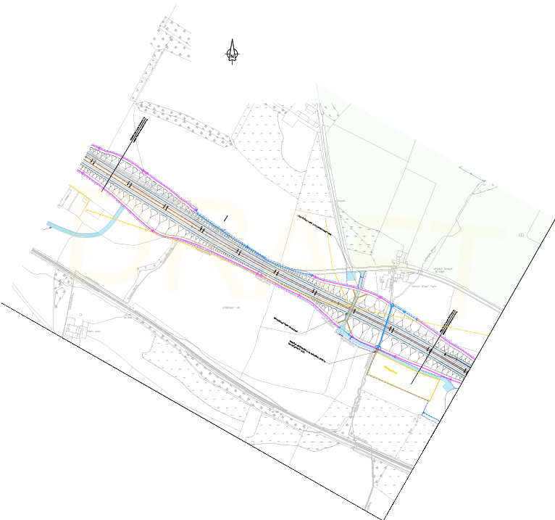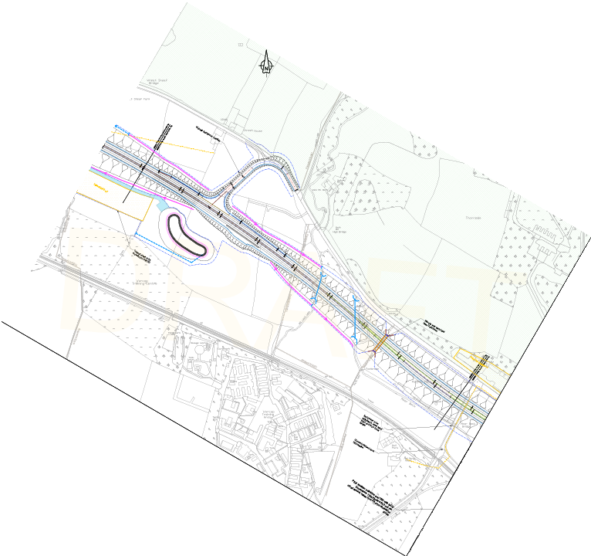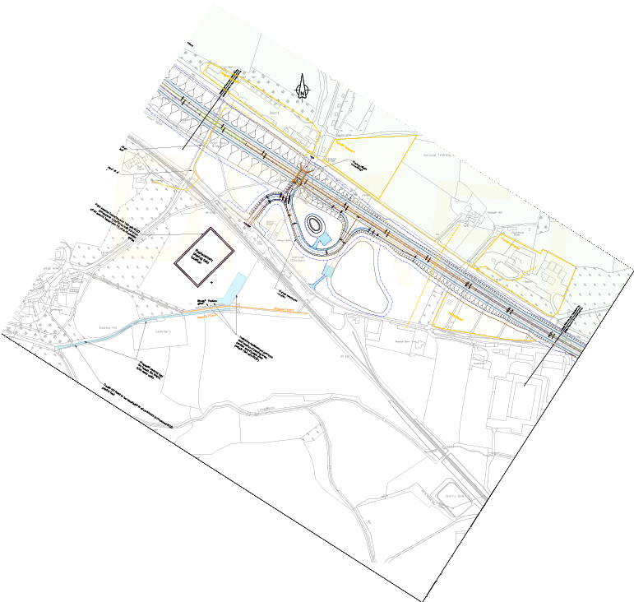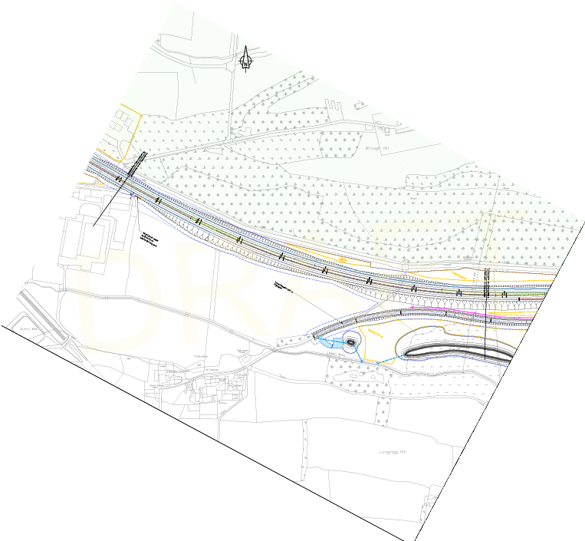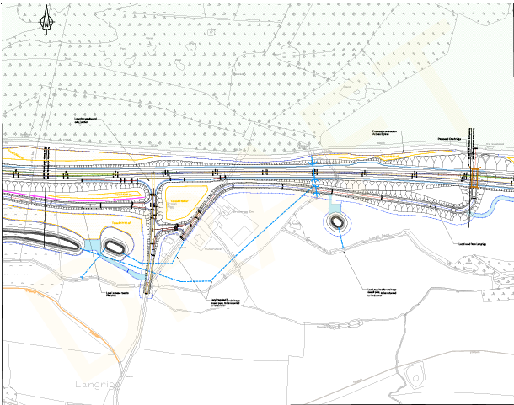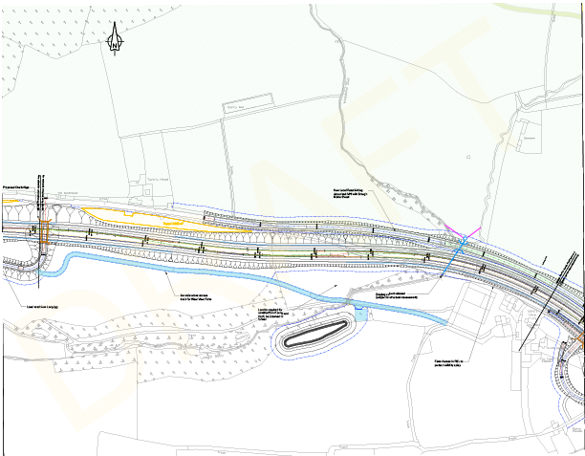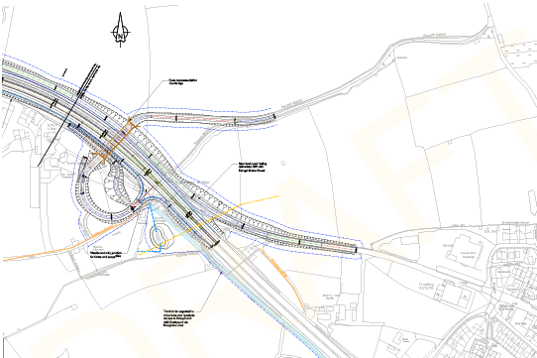
0km 0.2km 0.4km 0.6km 0.8km 1.0km 1.5km 2km
Drawing No: 101
Rev:
-
Scale: 1:20000 @ A3
Date: June 2021

