TABLE TENNIS CLUB 2021

Warcop Parish Hall

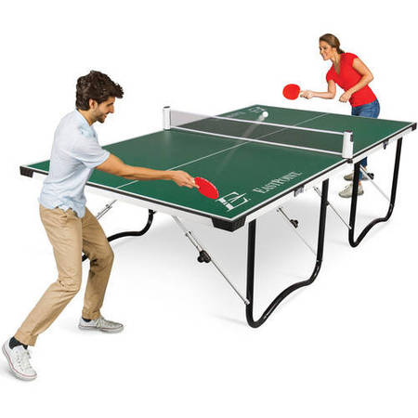

Monday Evenings 6:30-8:00 pm

Re-starts Monday 17th May

Current Covid restrictions: masks when not playing, hand sanitiser, table cleaning, no physical contact with players, no change of ends

- We have six tables, plus nets, bats and balls – bring your own bat if you prefer.
- Please wear trainers.
- This is a 1 hour 30-minute session for all ages and abilities - so have a knockabout, play singles, doubles or fun activities.
- Cost: Adults: £3, Children: £1, to cover hire of hall and to go towards new equipment.
- Ball machine to help you practise your shots!
- New members more than welcome

David Keetley Telephone: 41390

Everyone welcome!

