The Parish of Warcop with Musgrave
DECEMBER SERVICES
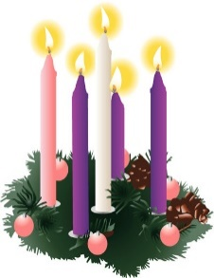
Sunday 6th December – 10.45am
St Columba’s Church Warcop
Holy Communion – Rev C Hicks

Sunday 13th December – 10am
St Theobald’s Church Musgrave
Holy Communion - Rev D Wood

Sunday 20th December – 10.45am
St Columba’s Church Warcop
Holy Communion – Rev J Clarke

Monday 21st December – 6pm
Warcop Parish Hall Carpark
Churches Together – Outdoor Carol Service

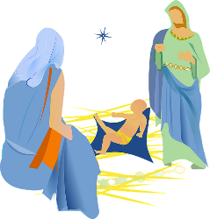
Thursday 24th December – 11.30pm
St Columba’s Church Warcop
Holy Communion – Rev J Clarke & Rev D Wood

Sunday 27th December – 10am
St Theobald’s Church Musgrave
Holy Communion – Rev D Wood

