# **Air Ambulance Bag Collection**

# **SATURDAY 28th NOVEMBER 2020**

**Warcop Parish Hall 09:00 – 11:00 am**

**Bags collected by GNAA van at 11:30 am**

**Bags located in newspaper boxes in**

**Warcop & Sandford**

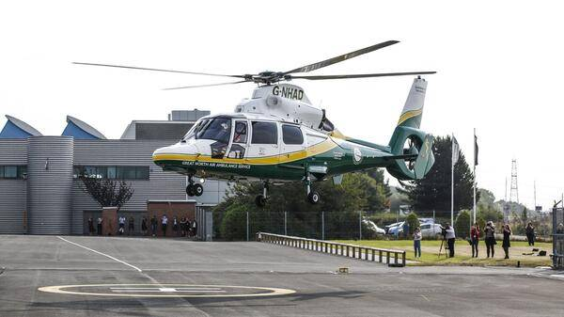

**Please donate your unwanted items which will support the Great North Air Ambulance appeal and help them to ease suffering and save lives in our area. They need £4.5 million per year to maintain the service. All proceeds from this re-cycling go to them. Visit** [**www.greatnorthairambulance.co.uk**](http://www.greatnorthairambulance.co.uk) **for more information.**

**PLEASE SOCIAL DISTANCE WEAR A MASK & SANITISE HANDS AT THE HALL.**

**Why not use this as a chance to have a good pre-Christmas clear out and bring items listed below to the Hall and leave outside. More bags available by phone.**

* **Clothing**
* **Bags**
* **Footwear**
* **Bed linen, towels & curtains**
* **Books, CDs & DVDs**
* **Mobile phones**
* **Ink/toner cartridges**
* **No bric-a-brac or electrical items please**

**Website:**[**www.warcop.org.uk**](http://www.warcop.org.uk)

**Phone: 017683 41390**

**Warcop Parish Hall**

**CA16 6NX**

