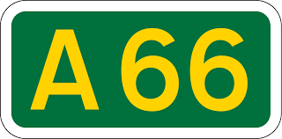 Alternative Appleby-Brough Route Survey
Warcop Parish Council has been lobbying Highways England to reconsider their Preferred Route Announcement for the new section of the dual carriageway A66 from Appleby bypass to Brough. Only one option (Option I) was ever offered to local residents. We believe that Highways England should re-consider a Northern route option to reduce the impact of noise, air and visual pollution, as well as the impact on property prices. Warcop Parish Council seeks to assess the strength of feeling for the two options and will pass on the results of this survey to Highways England, Natural England, local councillors and our MP.
This survey includes two route options I and I (North) shown on a map, the key reasons for each option, then a simple reply sheet with a box for you to tick which of the two you support. Each adult over 18 in your household may complete a form, which must be signed with your address and date. If you need extra copies there will be more available online at www.warcop.org.uk or phone 41390. You can see the HE preferred route booklet via this link: https://highwaysengland.citizenspace.com/cip/a66-northern-trans-pennine/results/pra_report_aw_lo_res.pdf
The deadline for the return of all completed forms is SATURDAY 31ST OCTOBER 2020 and forms can be placed in the survey boxes located in all the newspaper boxes or in the post box at Warcop Parish Hall. We will inform you of the results as soon as possible.
Thank you for helping with this important survey of local opinion.
David Keetley
Chair, Warcop Parish Council

Option I

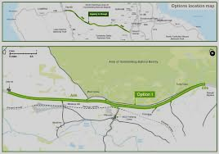

“The current carriageway between Café 66 and Wildboar Hill would be widened and utilised as the eastbound carriageway and a new westbound carriageway would be constructed directly to the south of the current A66. Between Wildboar Hill and the Brough Bypass a completely new dual carriageway would be constructed directly to the south of the current A66. The existing road would then be used for local access and pedestrians, walkers, cyclists and horse riders. New culverts (tunnels) would divert streams under the road at Moor Beck and Lowgill Beck. A new junction and bridge would provide access from the new road to Warcop.

Access to the proposed route from local roads would be limited to junctions at Flitholme, Landrigg, Sandford and Warcop which would make this section much less accident-prone. The existing A66 between Moor House and Turks Head would become part of the local road network for safer local access to nearby villages, especially for pedestrians, walkers, cyclists and equestrians. This option reduces the impact on the AONB to the north of the current A66 and provides continued access for local communities during construction. The new dual carriageway will connect back into the existing A66 at Brough bypass. Almost 75% of respondents were in favour of this single option.”

Option I (North)

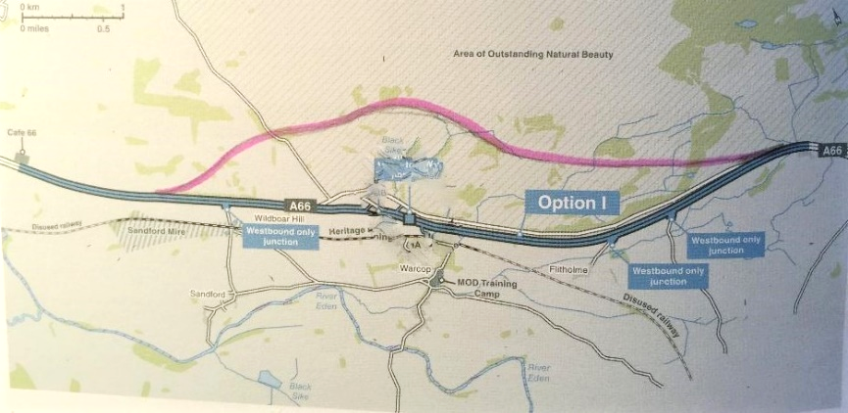

Our proposed northern alternative would take the new road across a small section of AONB from Brough, behind all MOD buildings and make use of natural valleys behind any settlements, before returning to the line of the existing road near to the Sandford junction or further west towards Café 66. This option would reduce noise, air and visual pollution from the village of Warcop and other affected properties near Sandford and Langrigg. It would only require two major east-west junctions at Sandford and west of Brough, thus avoiding the building of a large bridge at Warcop and the subsequent loss of the army playing field. The entire 5-mile stretch of the old A66 would be available for local traffic, walkers, cyclists and equestrians. Army access roads will be retained with appropriate bridges and no interference to MOD operations. All historic monuments and settlements would be avoided by this route. Property values will not be reduced by the increased proximity of this major road scheme. Construction will be more straightforward as the works will be entirely self-contained between the two junctions.

Only a small section of the MOD’s 24,000 acres would be required, as well as a small part of the AONB, Other major road schemes have been built across AONBs in the UK in exceptional circumstances, which we believe applies to our proposal. It is debatable how beautiful the landscape occupied by the army currently is, and there is also scope for expanding the AONB to the south of the existing road to incorporate more of the Eden Valley landscape. Finally, we believe that the northern route would be a spectacular driving experience which will take some 14,600 vehicles a day, including 30% HGVs, completely away from residential properties.
A66 Survey Return Sheet

Please tick in the box below the option you prefer for this route:

Option I

Option I (North)

Don’t know

Comments

Your Name: ____________________________________________________
Address: _______________________________________________________
______________________________________________________________
Signature: ___________________________
Date: _______________________________
Please return this sheet to the survey box in each of the newspaper boxes in the villages or in the external post box at Warcop Parish Hall. The deadline for returns is SATURDAY, 31ST OCTOBER.

Thank you for your help in completing this survey, the results of which will be passed on to Highways England, other relevant bodies as well as local residents.

Warcop Parish Council

