Warcop Parish Hall

Prize Bingo
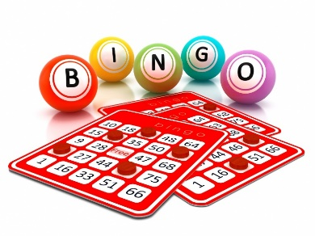

Friday 13th March
7.30pm

£1 / book
Includes refreshments
Free game for children during interval
Raffle

Donations for prizes and hamper items will be much appreciated. These can be left at the Café on Thursday mornings.
Thank you.

