Warcop Parish Hall
COFFEE MORNING
Saturday 12th October, 10:00 – 11:30 am
- PLUS, FROM 10:30 A SPECIAL “FIT4ALL” TASTER SESSION: GENTLE EXERCISE ACTIVITIES WITH ROO BANNISTER - including indoor bowls, curling and boccia amongst others. For those who would like to try a more gentle exercise session, have a go today and, if there’s enough interest, a new class might start.
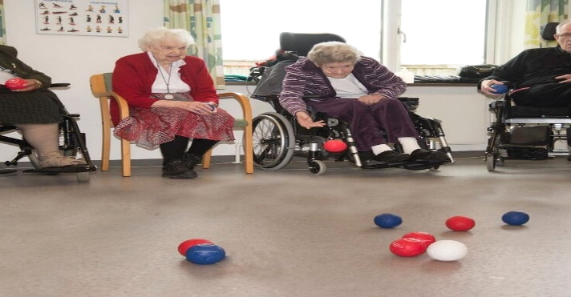
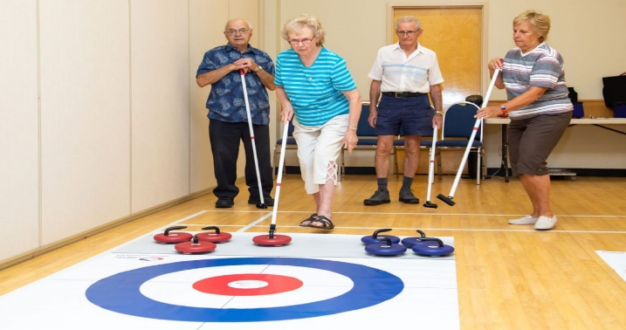

- Enjoy good company with tea, coffee and biscuits, plus some tasty extras: BACON ROLLS (vegetarian alternatives) & SCONES
- Browse our book collection in our expanding community library
- Purchase goods from our small community shop
- Everyone welcome: £1.50 each, including a free refill

Visit us at www.warcop.org.uk

