Warcop
Village Show

Sunday 23rd June

1pm - 4pm

Warcop Parish Hall

Refreshments available

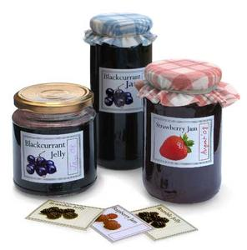
Baking
Preserves and Wine
Handicrafts
Photographs
Horticulture and Flowers
Children’s Section
Miscellaneous Section
Entries from children at the Primary School

