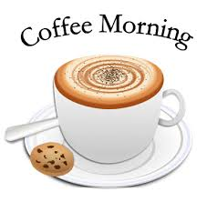
Warcop Parish Hall
COFFEE MORNING
Saturday 9th February 10:00 – 11:30 am
Special Event: Meet Your Parish Councillors
Hear about recent achievements, current issues and future plans.
Raise any concerns you might have before our next Parish Council meeting on 13th February

Please note: Future coffee mornings will have more speakers such as meeting your District and County Councillors, local community police officer, Great North Air Ambulance presentation, Community Heartbeat & Mountain Rescue presentations plus new occasional Farmers’ Market with local produce/crafts.
Tea, coffee and biscuits, plus some tasty extras:
BACON ROLLS (vegetarian alternatives) & SCONES
Browse our book collection in our community library.
Everyone welcome. £1.50 each, including free refill.

