Warcop
Village Show

Sunday 23rd June

1pm - 4pm

Warcop Parish Hall

Baking
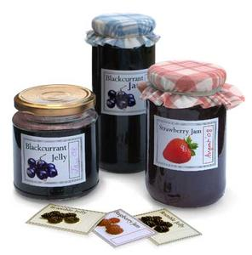
Preserves and Wine
Handicrafts
Photographs
Horticulture and Flowers
Children’s Section
Miscellaneous Section

30p entry for each class Children’s entries free

Entry forms with details of the classes in each section from:
the Parish Hall website www.warcop.org.uk
emailing: wizzylois1@btinternet.com or caz.cotehouse@yahoo.co.uk
telephoning: Caroline on 42900 or Hazel on 41034
also from the Parish Hall

