ART & CRAFT EXHIBITION 2019
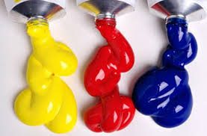
Warcop Parish Hall

Calling Local Artists & Craftspeople!
We’d like to hear from you if you are:
- Art groups
- Painters
- Sculptors
- Photographers
- Felt-makers
- Craft workers
- Wood turners
- Ceramicists
- Local schools
- Sugar craft
- Needlecraft
- Art suppliers

Following first three highly successful Art & Craft Exhibitions, we are pleased to announce our fourth exhibition in the light and bright new Warcop Parish Hall over the Bank Holiday weekend:
Saturday 4th May – Monday 6th May 2019, 10 - 4 pm
The event is a celebration of the extensive creative talent in our local community, so we would love to hear from you if you would simply like to display or sell your work to local people and visitors. Set up will be on Friday 3rd May 10:00 - 4:00 pm. This year we will again have a Private Viewing event to start our weekend on Friday 3rd May 7 – 9, including all artists, local dignitaries and the media. Again, this year we hope to put on demonstrations and workshops over the three days, run by attending artists/craftspeople for visitors to sign up for. We will publicise the event in the local media, websites, parish magazines and flyers in hotels, B&Bs and TICs.
The hall will be fully staffed over the Bank Holiday period and refreshments will be available. There will be raffle prizes, competitions and activities too.
For further information and to reserve a display space, contact: David Keetley on 017683 41390, Hazel Deighton on 017683 41034, email keetleyjd@sky.com or visit www.warcop.org.uk
