WANTED!
Volunteer Minibus Drivers
(Full training provided)
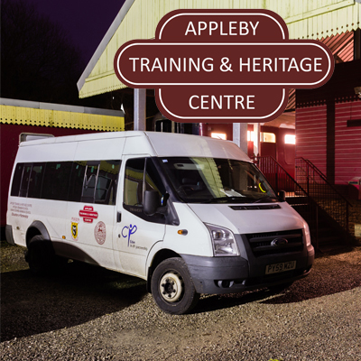
Warcop Parish Council has negotiated the hire of an Appleby Heritage Centre minibus to run a weekly link service from Warcop via Sandford to Appleby. This will link in with the first Appleby to Penrith 563 service at 09:47 and return to Warcop when the last bus arrives at Appleby at 14:24.
Initially this link bus will run on WEDNESDAYS.
Drivers will need to collect the bus from Appleby at 09:00 and return at 10:00 in the morning, and 2:15 and return at 3:15 in the afternoon.
If you would like to volunteer for an hour in the morning and the afternoon and help improve our access to community transport, please contact David Keetley on 017683 41390.

