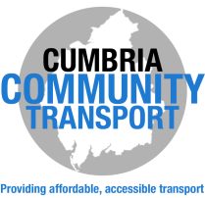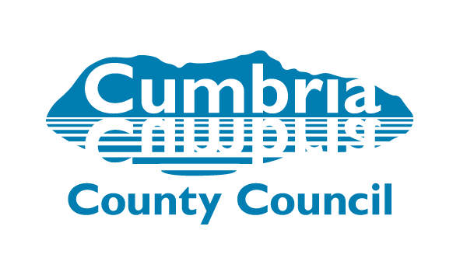
Improved Links from Warcop/Sandford to Appleby Questionnaire
Due to the withdrawal of the 563 service, and the introduction of the 574 service from Kirkby Stephen to Appleby, the Council is keen to look at alternative options for Warcop and Sandford that are left with no transport.
If you could please take a few minutes to complete the information on the reverse and return to the address in the contact details asap, this would help in looking at the options for Community Wheels.
What is Community Wheels?
“Community Wheels” is an initiative being developed by Cumbria County Council, funded with “Community Transport Transition Fund” allocated by the Department of Transport in 2012/13 as part of a nationwide settlement to enhance community transport.
A Community Minibus will be driven by local volunteers in areas where scheduled bus services are not suitable or where users of other County community transport services could be more effectively transported together. Passengers will need to be members of the Rural Wheels scheme and will pay a fare based on mileage travelled. Journeys will be pre-booked. Concessionary NoWcards are not able to be used on Community Wheels as it is not a registered service.
Minibuses may be available for hire to “not-for-profit” groups to generate additional income, enhance service viability and provide another transport solution.
The first Community Wheels started on 18th September 2013 in the Lakes and Lyth area providing Wednesday morning transport into Kendal from Crook, Winster, Crosthwaite, Underbarrow and Brigsteer. Since then in 2016, there has also been a School Holiday service set up in Alston to go to Carlisle on Thursdays. Both of these services are co-ordinated locally through Steering Groups. Cumbria Community Transport also run a service from Rockcliffe to Carlisle on Fridays and another service on Tuesdays from Anthorn to Wigton and Uldale to Wigton.
The County Council working with Appleby Heritage Centre, Cumbria Community Transport and a local steering group to look into possible routes, frequency and fares, provide a rota and recruit volunteer drivers and customers to ensure the service is promoted and used enough to be financially viable.
For further information, please contact:
Voluntary Transport Officer, Cumbria County Council,
Parkhouse Building, Baron Way, Kingmoor Business, Park, Carlisle, Cumbria, CA6 4SJ (alternatively questionnaires can be left at Warcop Village Hall).
Telephone: 07788 396194
Email: integrated.transport@cumbria.gov.uk Website: www.cumbria.gov.uk/communitywheels
15/12/2016
QUESTIONNAIRE
Please circle the appropriate answers and provide details where requested:
Name
Address
Email
Contact Telephone Number
Do you use any of the following Community Transport Services?
Voluntary Social Car Scheme YES NO
Rural Wheels YES NO
Community Minibus Sharing Scheme? YES NO
Would you use a pre-booked community minibus to travel from Warcop/Sandford to Appleby and return? YES NO

Would you use the 563 bus from Appleby to Penrith (arriving Penrith 10:45 and returning 13:40) if a connection to it was provided? YES NO

Do you hold a Concessionary NoWCard bus pass? YES NO

Why do you need to travel? Doctors, Social, Shopping, Dentist, Optician, Hospital, Transport Connection, Social, Church, Library, Hair/Beauty, Bank, Other (please state which below):

How often would you travel? Weekly, Fortnightly, Monthly, Less Frequently
What is the best day of the week for you to travel? Monday, Wednesday, Friday
Please circle what time(s) you would travel: 9.45am (to Appleby), 11.15am (from Appleby), 2.25pm (from Appleby)
Would you be interested in being a volunteer minibus driver/or to find out more information? YES NO

Thank you for your time and input into completing this questionnaire.
Please return to Warcop Village Hall or post to Parkhouse Building, Baron Way, Kingmoor Business, Park, Carlisle, Cumbria, CA6 4SJ.
Questionnaires will be analysed from 31st March 2018

