ART EXHIBITION 2017
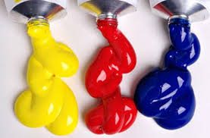
Warcop Parish Hall

Calling All Artists!
We’d like to hear from local:

- Art groups
- Painters
- Sculptors
- Photographers
- Craft workers
- Woodturners
- Local primary & secondary schools

Following its first fantastically successful first Art & Craft Exhibition last year, we are pleased to announce our second exhibition in the light and bright new Warcop Parish Hall over the Bank Holiday weekend:
29th April – 1st May 2017 (Saturday to Monday 10 - 4 pm)
The event will be a celebration of the amazing creative talent in our local community, so we would like to hear from you if you would simply like to display, or sell, your work to local people and visitors. We will publicise the event in the local media, websites, parish magazines and flyers in hotels, B&Bs and TICs.
The hall will be fully staffed over the Bank Holiday period and refreshments will be provided. We will have raffle prizes, competitions and activities too.
For further information and to reserve a display space, contact:
David Keetley on 017683 41390, Hazel Deighton on 017683 41034, email keetleyjd@sky.com or go to our village website www.warcop.org.uk
