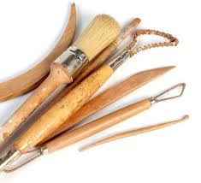

WARCOP ART & CRAFT EXHIBITION
Come along and enjoy the work of local artists, craftspeople and children at Warcop’s Parish Hall. Refreshments, activities for children, raffle and prizes. Many items available for purchase.
MINIBUS SHUTTLE TIMETABLE
SUNDAY 6TH MAY 2018
Appleby Moot Hall | 10:15 am
Warcop Parish Hall | 10:35 am
Kirkby Stephen Market Square | 11:00 am
Warcop Parish Hall | 11:20 am
Appleby Moot Hall | 11:45 am
Warcop Parish Hall | 12:10 pm
Kirkby Stephen Market Square | 12:35 pm
Kirkby Stephen Market Square | 1:00 pm
Warcop Parish Hall | 1:20 pm
Appleby Moot Hall | 1:45 pm
Warcop Parish Hall | 2:05 pm
Kirkby Stephen Market Square | 2:30 pm
Warcop Parish Hall | 2:50 pm
Appleby Moot Hall | 3:20 pm
Voluntary contribution of £2 per person per journey to cover fuel and hire, thank you.
Minibus courtesy of Appleby Heritage & Training Centre.
Your drivers are volunteers.

