ART & CRAFT EXHIBITION 2018
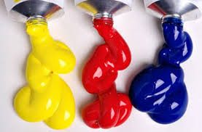
Warcop Parish Hall

Calling All Artists!
We’d like to hear from local:
- Art groups
- Painters
- Sculptors
- Photographers
- Felt-making
- Craft workers
- Wood turners
- Ceramicists
- Local schools
- Sugar craft
- Needlecraft
- Art suppliers

Following its first two fantastically successful first Art & Craft Exhibitions, we are pleased to announce our third exhibition in the light and bright new Warcop Parish Hall over the Bank Holiday weekend:
5th May – 7th May 2018 (Saturday to Monday 10 - 4 pm)
The event is a celebration of the amazing creative talent in our local community, so we would love to hear from you if you would simply like to display or sell your work to local people and visitors. Set up will be on Friday 4th May 10:00 - 4:00 pm. This year we will have a Private Viewing event to start our weekend on Friday 4th May, 7 – 9 pm, for invited guests only. Also new this year also are demonstrations and workshops run by attending by artists/craft workers for people to sign up for. We will publicise the event in the local media, websites, parish magazines and flyers in hotels, B&Bs and TICs. We are also planning to run shuttle minibuses from Appleby and Kirkby Stephen to bring even more people to the exhibition.
The hall will be fully staffed over the Bank Holiday period and refreshments will be provided. There will be raffle prizes, competitions and activities too.
For further information and to reserve a display space, contact: David Keetley on 017683 41390, Hazel Deighton on 017683 41034, email keetleyjd@sky.com or visit www.warcop.org.uk
