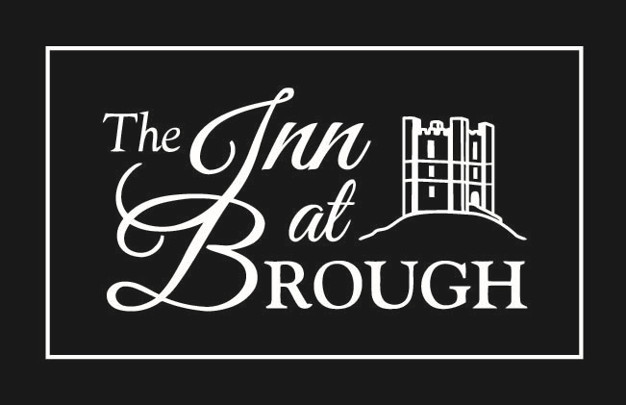

CALL IN FOR

- A Friendly Welcome
- Superb Food
- Good Beer
- Fine Wines
- Comfortable Beds

Our function suite is now open and free to hire for parties of 10 to 100
so
Why not hold your next party or special occasion here?

Tel: 01768 341252
EMAIL: bookings@theinnatbrough.co.uk
www.theinnatbrough.co.uk

